Python and Deep Learning

Lab Assignment 1

Submitted by

Vamsi Krishna Challa

16242688

**Objective:**

To perform various operations like Manipulating, accessing, assessing, comparing strings and lists.

**Features:**

In this assignment we access python inbuilt features to

1. Compare the strings and return the results
2. Access lists to perform required operations
3. Perform operations on loop to perform password authorization

**Configuration:**

Software used: Python 3.4

IDE: PyCharm

**Input / Output:**

1. **Program for password authorization**

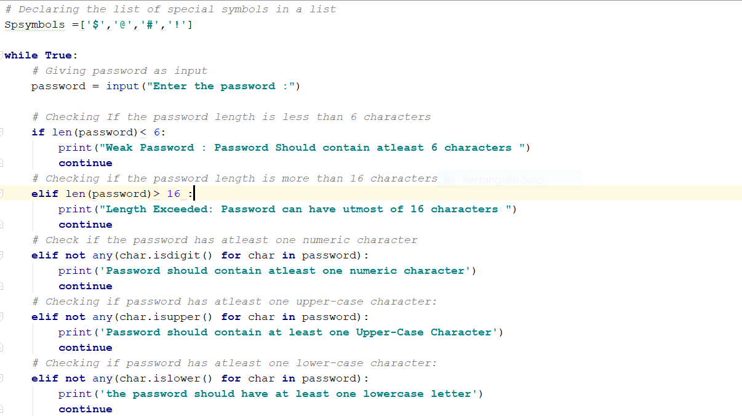

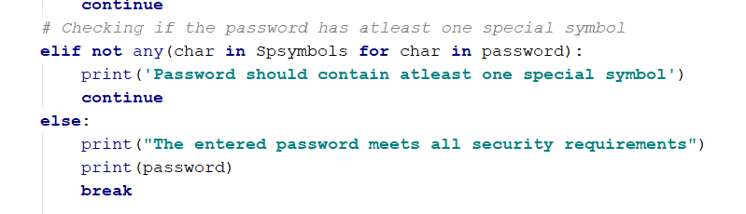



2.

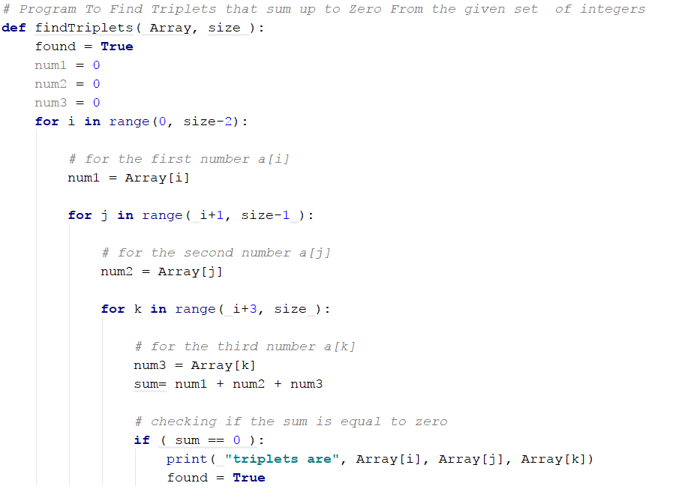

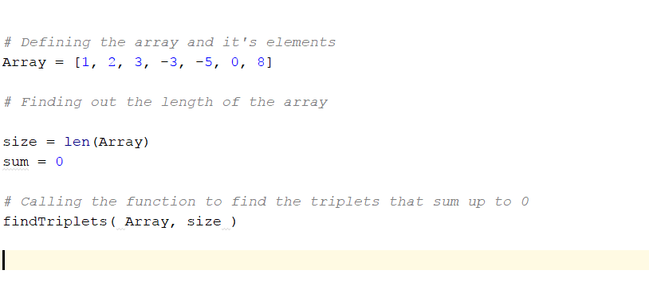



3.

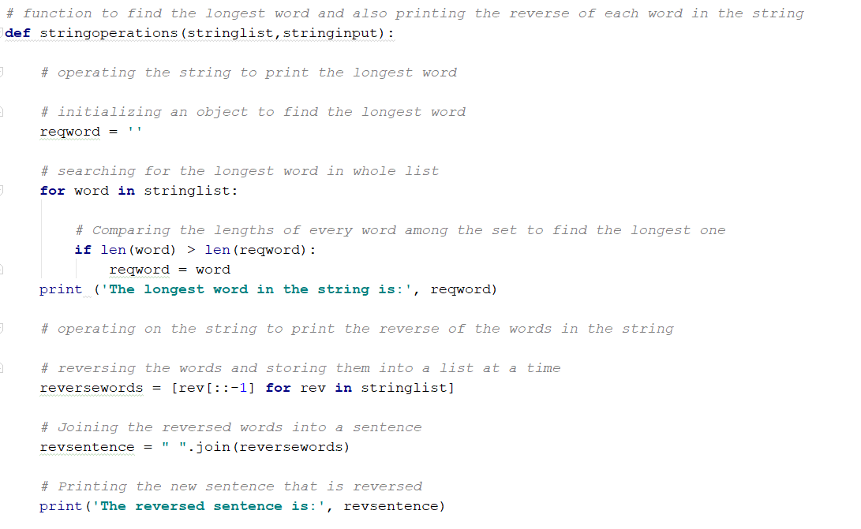

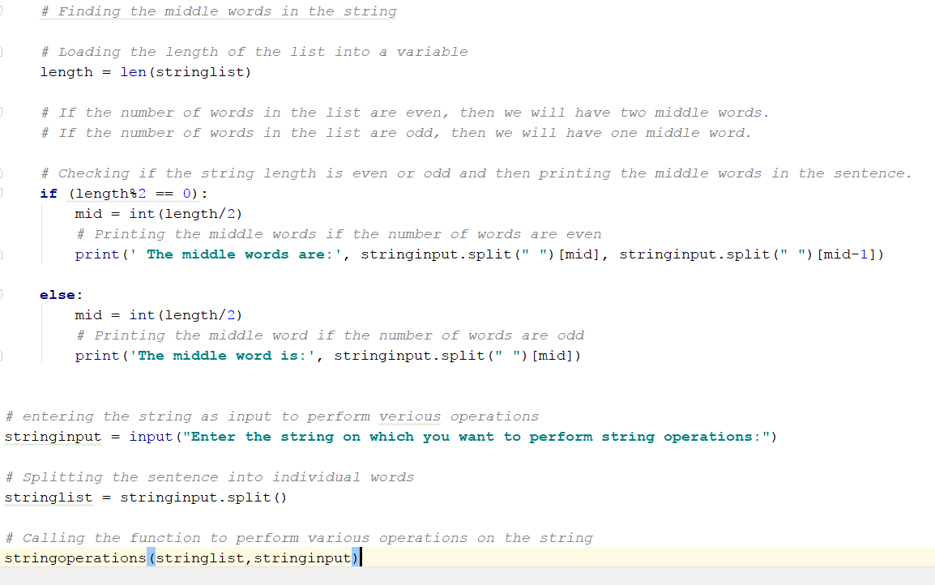

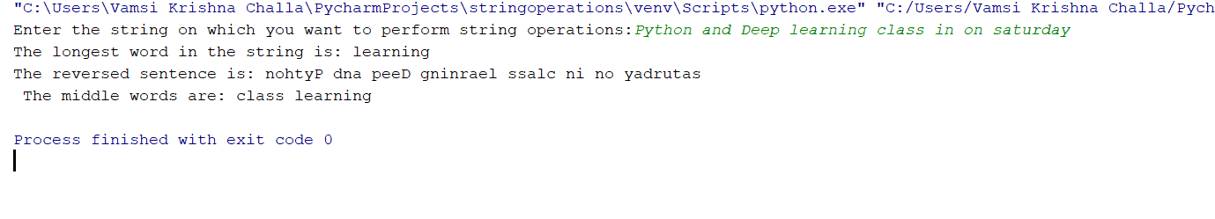

4.

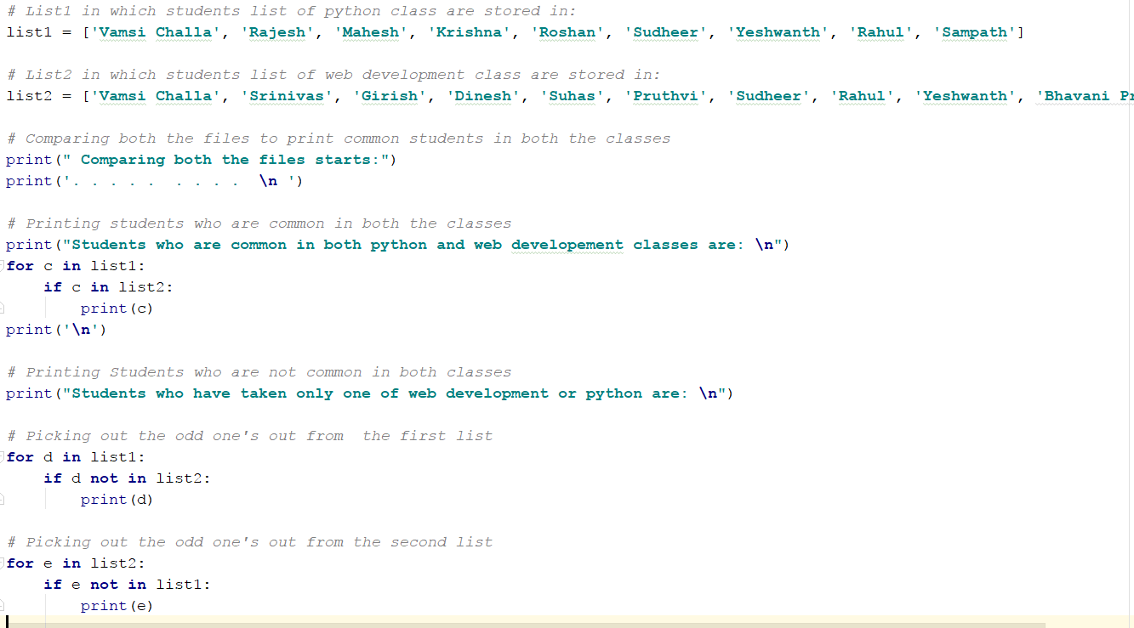

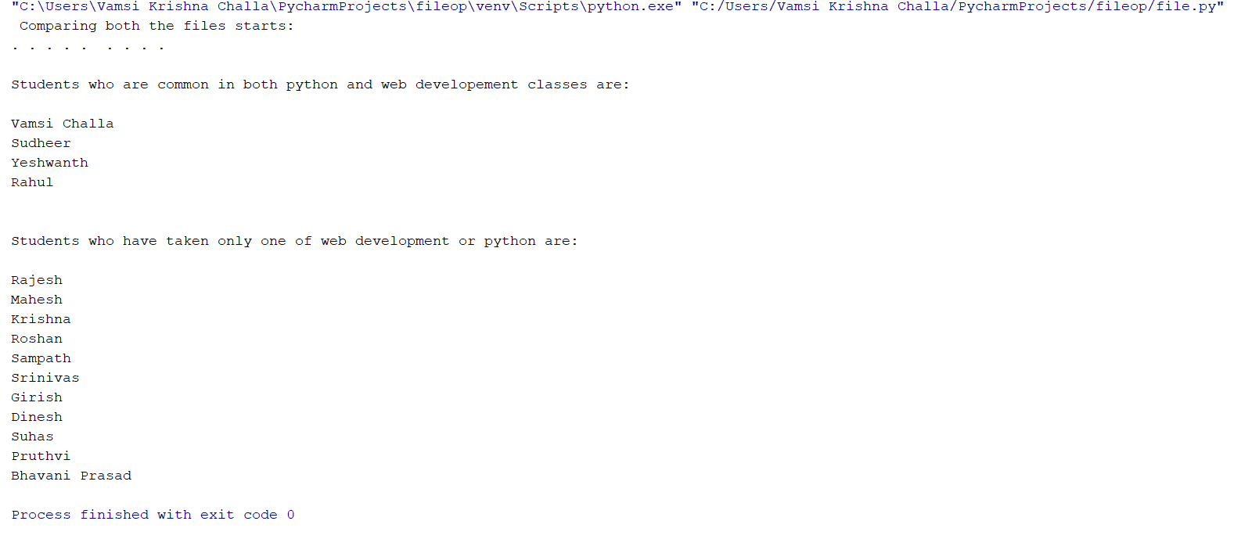

**Implementation:**

Program 1:





In this program, we implement password authorization to check whether the password meets the security requirements or not.

Initially we declare the special symbols list. Later we call a variable and input the password into it. Now we check for various conditions to match with the security requirements. We use isdigit() function to verify whether there are numbers in password, islower() function to verify whether there are any lowercase letters, isupper() function to verify whether there are any uppercase letters, len() function to get the length and check for the required length.

Result:



2. Program to perform various operations on strings:





Initially we would declare a function to perform various operations on strings. To reverse the string that we have taken as input, we use ‘::-1’ which would make us the system to read the string from the last index of each word in the string till the first index of each word in the string. This would print the reverse if the entered string.

Now to print longest word, we would perform linear comparison using the lengths of each word in the string. We would initially declare a variable and then keep storing the lengths of the words and comparing it with the later ones and then update if the word length is greater than the previous one. Then print the word corresponding to the word with the longest length.

Now in this part, we need to print the middle words in the string. We make the code basing on the logic that, if the number of words in the string are even, then the number of middle words will be two and if the number of words in the string are odd, then the number of middle words is one. For identifying this, we first count the number of words in the string and then compare it with either odd or even and then print the middle words using if / else condition.

Result:



1. Program for find out triplets that sum up to zero



Here we search for triplets that would sum up to zero in the whole list of numbers. Initially we would declare a list with numbers. Initialize three variables to store three numbers. Now use for loops to search for each number over the other in the list which would sum up to zero forming triplets. We use inbuilt true/false value to continue iterating over the loops and find if any other triplets exist.

Result:



1. Program to print both common elements and uncommon elements by comparing two lists:



Now we declare two list with student names of python in list1 and student names of web development class in list2. Now we need to compare both the lists to print the students who have taken both python and web development classes. We use for loop to compare every student in one list with every other student in the other list and then print common students in both the lists.

Now we need to print the list of students who have taken only one of the both python or web development classes. Now we perform odd out picking search by comparing both the list and then printing the students who are not in both the lists.



**Deployment:**

In the first part of the assignment, we have written a program in Pycharm, for validating the password, whether it meets the security requirements or not. Once we complete writing the program, we would then run the script. Python to most of the point follows top-down approach. It’s not like compilation-based language, but interpreter language. After that function is called and input is taken, it would run all the rules through every validation rule and verify whether the password meets security requirements or not.

In the second part, we have written program to perform various operations on strings and get the required results. Once we take the string input, then we would pass the string as input then perform operations to reverse the string, print middle words of the string and to print the longest word in the string.

In the third part, we have written program to find the triplets from the list that would sums up to zero. When we run the program, the list of numerical entries is passed on to the function and every number is added to any other two numbers in the list and is verified whether the list sums up to zero or not.

In the fourth part, we would compare two individual lists and then traverse them accordingly for user-request based results. We declare two lists with students of two different classes and then pass them on to the function to compare both the lists. After comparison, it would generate the set of students who are in both the classes and also students who have taken only one class.

**Limitations:**

This implementation has several limitations due to program scope. We have restricted some parts to static based retrieval, making it not feasible for new set of values. If we perform dynamic based, then we can perform operations more efficiently.

For instance, in the case of the first part of assignment we have just written the program to validate it on the Pycharm IDE, but this piece of code cannot be implemented directly to real-time environment. If this needs to be connected to web application, we need to implement data base connections and allocate dedicate memory for it to work.

In the third part of the assignment, we have given the input list statically, making it not feasible for new set of values. This increases the cost, as we need to write a new program every time we need to perform the action. If it is implemented dynamically, we would have scope to use it on wide range of values.

References:

* [www.stackoverflow.com](http://www.stackoverflow.com)
* [www.geekforgeeks.com](http://www.geekforgeeks.com)
* [www.tutorialspoint.com](http://www.tutorialspoint.com)
* [www.python.org](http://www.python.org)